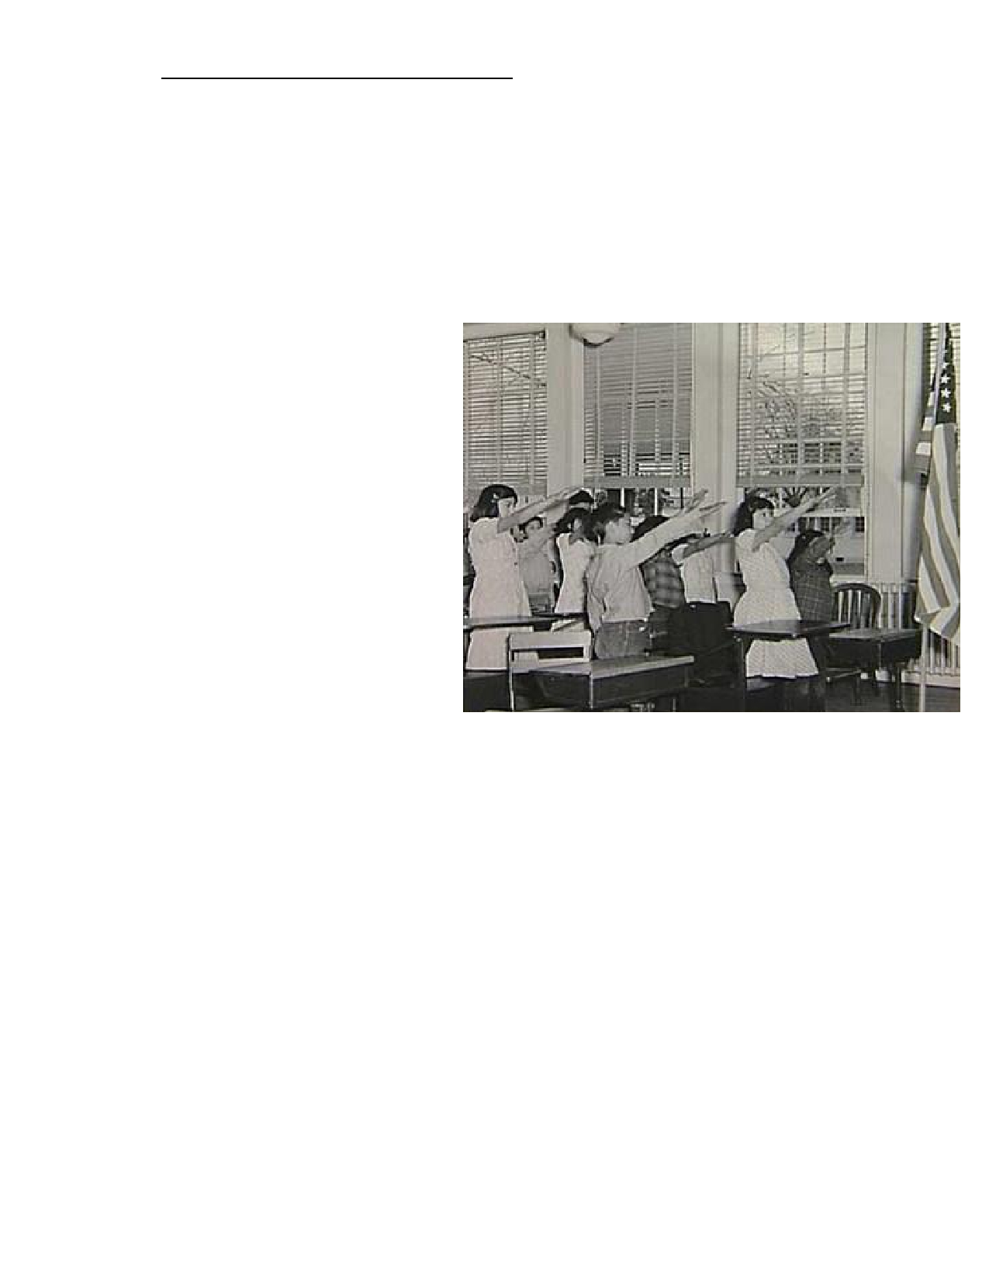
Name: AP U.S. Government and Politics

Freedom of Speech in Public Schools

Should students in public
Schools be forced to say the
pledge of allegiance?

Minersville School District v. Gobitis
(1940)
Facts of the Case: Lillian and William
Gobitis were expelled from the public
schools of Minersville, Pennsylvania,
for refusing to salute the flag as part of
a daily school exercise. The Gobitis children were Jehovah's Witnesses; they believed that such a gesture of
respect for the flag was forbidden by Biblical commands.

Constitutional Question: Did the mandatory flag salute infringe upon
liberties protected by the First and
Fourteenth Amendments?

Conclusion: No.

From the Majority Opinion: ―Even
if it were assumed that freedom of
speech goes beyond the historic concept of full opportunity to utter and to disseminate views, however. . . offensive to dominant opinion. . . , the question remains whether school children,
like the Gobitis children, must be excused from conduct required of all the other children in
the promotion of national cohesion. We are dealing with an interest inferior to none in the hierarchy of legal values. National unity is the basis of national security. . . .

―The ultimate foundation of a free society is the binding tie of cohesive sentiment. Such a
sentiment is fostered by [the] spirit which may serve to gather up the traditions of a people, transmit them from generation to generation, and . . . create that continuity of a . . .
civilization. ‗We live by symbols.' The flag is the symbol of our national unity, transcending all internal differences, however large, within the framework of the Constitution. . . .

―A society. . . may, in self-protection, utilize the educational process for inculcating those
almost unconscious feelings which bind men together in . . . loyalty, whatever may be their
lesser differences and difficulties. That is to say, the process may be utilized so long as men's right to believe as they please, to win others to their way of belief, and their right to assemble
in their chosen places of worship. . . are [also] fully respected.‖

West Virginia State Board of Ed. v. Barnette (1943)
Facts of the Case: The West Virginia Board of Education required that the flag salute be
part of the program of activities in all public schools. All teachers and pupils were required to
honor the Flag; refusal to salute was treated as "insubordination" and was punishable by expulsion and charges of delinquency.

Constitutional Question: Did the compulsory flag-salute for public schoolchildren violate
the First Amendment?

Conclusion: In a 6-to-3 decision, the Court overruled its decision in Minersville School
District v. Gobitis and held that compelling public schoolchildren to salute the flag was unconstitutional.

From the Majority Opinion: ―It is now a commonplace that censorship or suppression of
expression of opinion is tolerated by our Constitution only when the expression presents a
clear and present danger of action of a kind the State is empowered to prevent and punish. . . .
[H]ere, [the government is unable to show] that remaining passive during a flag salute ritual creates a clear and present danger that would justify an effort even to muffle expression. . . .

―[Attempts] to coerce uniformity of sentiment . . . have been [made] by many . . . evil men. . . .
Those who begin coercive elimination of dissent soon find themselves exterminating dissenters. . . .

―The case is made difficult . . . because the flag involved is our own. Nevertheless, we apply
the limitations of the Constitution with no fear that freedom to be intellectually . . . diverse . . .
will disintegrate [society]. To believe that patriotism will not flourish if patriotic ceremonies
are voluntary. . . instead of . . . compulsory. . . is to [have little faith in the] appeal [of
America's] institutions to free minds. We can have intellectual individualism and the rich
cultural diversities that we owe to exceptional minds only at the price of occasional
eccentricity and abnormal attitudes. When they are so harmless to others or to the State as those we deal with here, the price is not too great. . . .

―If there is any fixed star in our constitutional constellation, it is that no official, high or petty,
can prescribe what shall be orthodox in politics, nationalism, religion, or other matters of
opinion, or force citizens to confess by word or act their faith therein. If there are any
circumstances which permit an exception, they do not now occur to us.‖

Does political speech interfere with the public schools' mission
to educate students?

Tinker v. Des Moines Independent Community School District (1968)
Facts of the Case: John Tinker, 15 years old, his sister Mary Beth Tinker, 13 years old, and
Christopher Echardt, 16 years old, decided along with their parents to protest the Vietnam
War by wearing black armbands to their Des Moines schools. Upon learning of their
intentions, and fearing that the armbands would provoke disturbances, the principals of the Des Moines school district resolved that all students wearing armbands be asked to remove

2

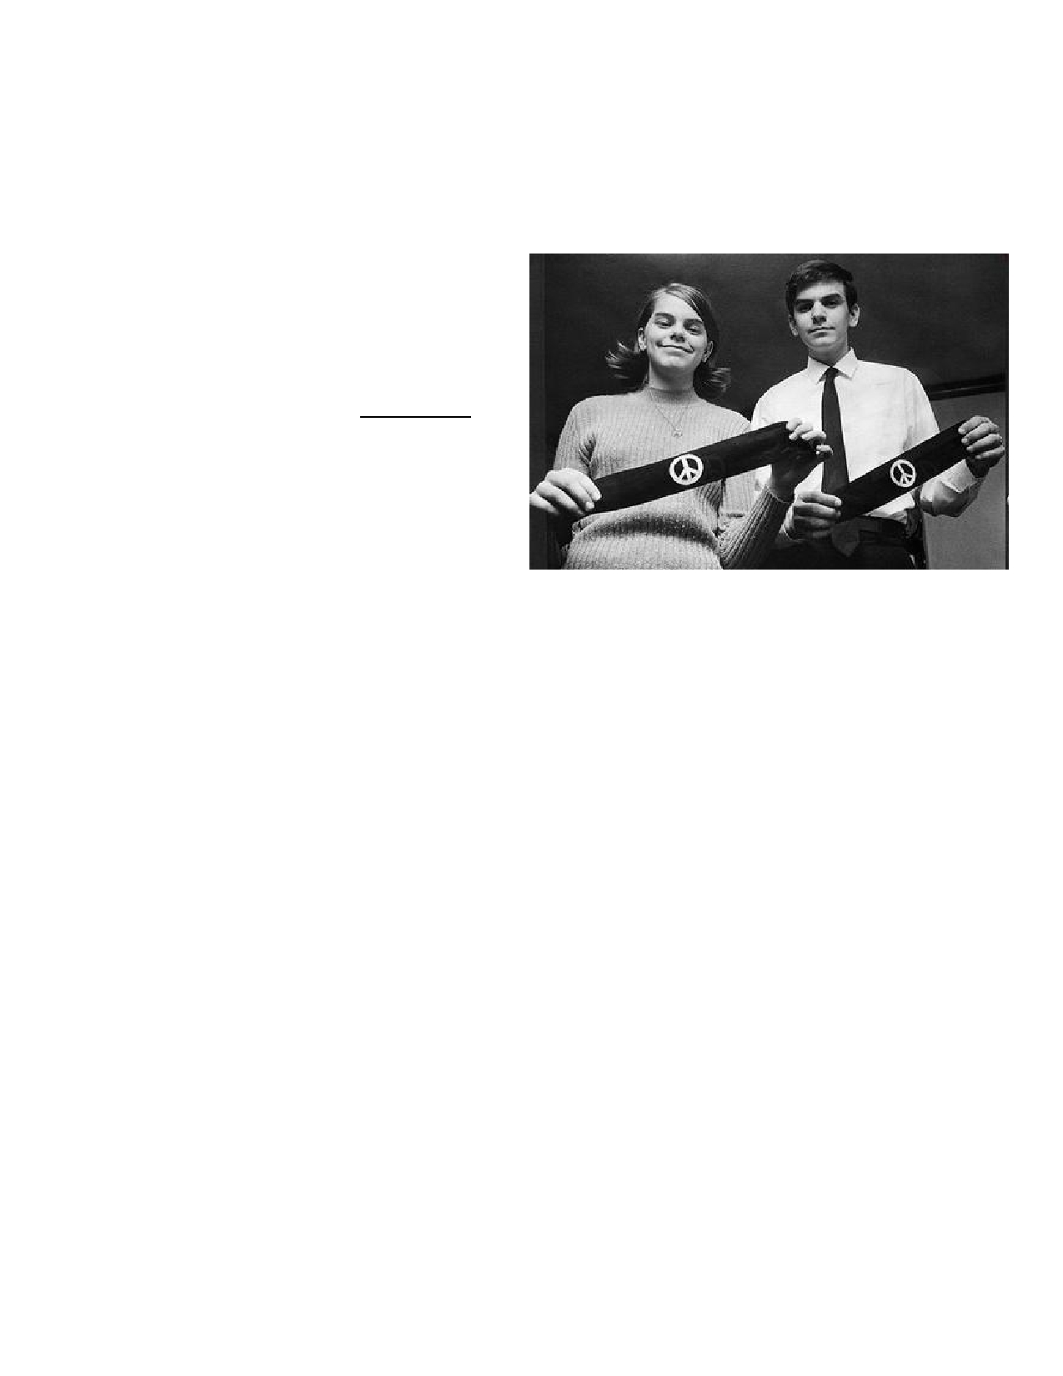
them or face suspension. When the Tinker siblings and Christopher wore their armbands to
school, they were asked to remove them. When they refused, they were suspended.

Constitutional Question: Can the Des Moines school district prohibit the wearing of
armbands in public school as a form of symbolic protest?

Conclusion: No.

From the Majority Opinion: ―As we
shall discuss, the wearing of armbands in the circumstances of this case was entirely
divorced from actually or potentially
disruptive [behavior] by those participating
in it. It was closely akin to ‗pure speech. . .
.'

―It can hardly be argued that either
students or teachers shed their
constitutional rights to freedom of speech
or expression at the schoolhouse gate. This has been the unmistakable holding of this Court for almost 50 years. . .

―Our problem lies in the area where students in the exercise of First Amendment rights collide with the rules of the school authorities. . . .

―The school officials banned and sought to punish [the Tinkers] for a silent, passive expression of opinion, unaccompanied by any disorder or disturbance on the part of
petitioners. There is here no evidence whatever of petitioners' interference. . . with the
schools' work or of collision with the rights of other students to be secure and to be let alone.
Accordingly, this case does not concern speech or action that intrudes upon the work of the schools or the rights of other students….

―The District Court concluded that the action of the school authorities was reasonable because
it was based upon their fear of a disturbance from the wearing of the armbands. But, in our
system. . . fear . . . of disturbance is not enough to overcome the right to freedom of
expression. . . . Any word spoken, in class, in the lunchroom, or on the campus, that deviates
from the views of another person may start an argument or cause a disturbance. But our
Constitution says we must take this risk. . . and our history says that it is this sort of
hazardous freedom - this kind of openness - that is the basis of our national strength and of the independence and vigor of Americans who grow up and live in this relatively permissive… society.

In order for the State in the person of school officials to justify prohibition of a particular
expression of opinion, it must be able to show that its action was caused by something more
than a mere desire to avoid the discomfort and unpleasantness that always accompany an unpopular viewpoint. . . .

―In our system, state-operated schools may not be enclaves of totalitarianism. School officials
do not possess absolute authority over their students. Students in school, as well as out of
3

school, are ‗persons' under our Constitution. They are possessed of fundamental rights which
the State must respect, just as they themselves must respect their obligations to the State. In
our system, students… may not be confined to the expression of those sentiments that are officially approved. In the absence of a specific showing of constitutionally valid reasons to regulate their speech, students are entitled to freedom of expression of their views. . . .

―A student's rights, therefore, do not embrace merely the classroom hours. When he is in the
cafeteria, or on the playing field, or on the campus during the authorized hours, he may
express his opinions, even on controversial subjects like the conflict in Vietnam, if he does so
without ‗materially and substantially interfer[ing] with the requirements of appropriate
discipline in the operation of the school' and without colliding with the rights of others. But
conduct by the student, in class or out of it, which for any reason - whether it stems from
time, place, or type of behavior - materially disrupts classwork or involves substantial
disorder or invasion of the rights of others is, of course, not [protected] by the constitutional
guarantee of freedom of speech.‖

From a Dissenting Opinion: ―I think the record overwhelmingly shows that the armbands
did exactly what the elected school officials and principals foresaw they would, that is, took
the students' minds off their classwork and diverted them to thoughts about the highly
emotional subject of the Vietnam war. And I repeat that, if the time has come when pupils of state-supported schools, kindergartens, grammar schools, or high schools, can defy and flout orders of school officials to keep their minds on their own schoolwork, it is the beginning of a new revolutionary era of permissiveness in this country fostered by the judiciary. . . .

―One does not need to be a prophet or the son of a prophet to know that, after the Court's holding today, some students in Iowa schools - and, indeed, in all schools - will be ready,
able, and willing to defy their teachers on practically all orders. This is the more unfortunate
for the schools since groups of students all over the land are already running loose,
conducting break-ins, sit-ins, lie-ins, and smash-ins [in protest of the Vietnam War and as part of civil rights protests]. Many of these student groups, as is all too familiar to all who
read the newspapers and watch the television news programs, have already engaged in
rioting, property seizures, and destruction. They have picketed schools to force students not
to cross their picket lines, and have too often violently attacked earnest but frightened students who wanted an education that the pickets did not want them to get. Students
engaged in such activities are apparently confident that they know far more about how to operate public school systems than do their parents, teachers, and elected school officials.

Chandler v. McMinnville School District (U.S. Court of Appeals, 9th Circuit,1992)
School teachers in McMinnville, Oregon, went on strike for better pay and working
conditions. The school fired them and hired new teachers, which upset many students. Two
students, especially angry because their fathers were among the dismissed teachers, wore
buttons to school - and gave them to other students - that said, ―No scabs,‖ ―I'm not
listening, scab,‖ ―Do scabs bleed?,‖ ―Scab we will never forget,‖ ―Students united for a fair settlement,‖ and ―We want our real teachers back.‖ (Scab is derogatory slang for someone
who takes the job of a striking worker.)

The two students were suspended for refusing to remove the ―scab‖-related buttons, which
the school system claimed to be ―disruptive.‖ The students then brought a First Amendment

4

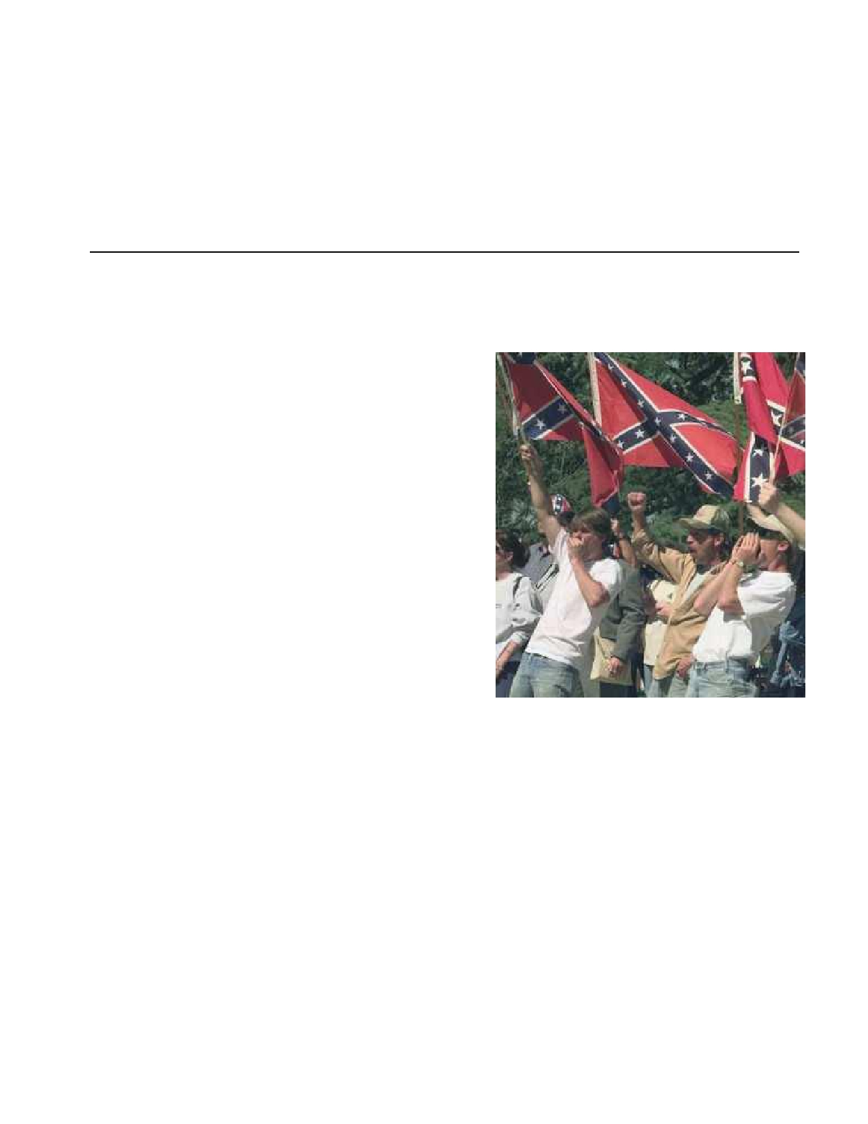
lawsuit, claiming that they had a right to wear political buttons and that they were being
punished for leading a protest against the firings.

The district court upheld their suspensions, finding that the anti-―scab‖ buttons were
―offensive‖ and ―inherently disruptive.‖ The students appealed, arguing that their speech was
nonviolent political expression that did not disrupt the school. The case went to the Ninth
Circuit Court of Appeals. It reversed the district court and found that the students were
entitled to wear the anti-―scab‖ buttons because their message was political and nonviolent.

Should a school prohibit the wearing of offensive slogans or symbols?

Melton v. Young (U.S. Court of Appeals, 6th
Circuit, 1972)
Brainerd High School in Chattanooga, Tennessee
was a formerly all-white school that was
desegregated in 1966, twelve years after the Brown
v. Board of Education decision. In 1969, the
student body consisted of 170 black students and 1,224 white students.

For several years in the late 1960s, there had been racial conflict and fights among students over the
school's use of the Confederate flag as an official
school symbol. In response, the school dropped the Confederate flag and the song Dixie from its school functions (although it kept ―the Rebels‖ for its team name).

In 1970, a white student at Brainerd was suspended
for wearing a jacket with the confederate battle flag emblem on his sleeve.

The U.S. Court of Appeals, 6th Circuit, upheld the boy's suspension.

From the Majority Opinion: ―This is a troubling case; on the one hand we are faced with
the exercise of the fundamental constitutional right to freedom of speech, and on the other
with the oft conflicting, but equally important, need to maintain decorum in our public
schools so that the learning process may be carried out in an orderly manner. It is abundantly clear that this Court will not uphold arbitrary or capricious restrictions on the exercise of such
jealously guarded and vitally important constitutional tenets. However, it is contended here
that the circumstances at the time of appellant's suspension were such that the District Court
could properly find that ‗the Principal had every right to anticipate that a tense, racial
situation continued to exist at Brainerd High School [at] the school . . . and that repetition of
the previous year's disorders might reoccur if student use of the Confederate symbol was
permitted to resume.'

5

―In the . . . case of Tinker v. Des Moines . . . the Supreme Court stated. . . that student conduct
which ‗materially disrupts class work or involves substantial disorder or invasion of the rights
of others' is not afforded the cloak of protection provided by the First Amendment.‖

From the Dissenting Opinion: ―It is my firm conviction that the Principal in suspending
the student simply over-reacted and was motivated by the kind of ‗undifferentiated fear or
apprehension of disturbance' which the [Supreme Court] in Tinker held to be insufficient to
overcome the right to freedom of expression. True enough, in this case the Principal was
aware of the disturbances which had occurred during the prior school year, but he failed to
take into account, in acting so hastily. . . , the following differentiating factors:

1. ―The protests of the previous year were against a group of school symbols [for example,
the Confederate fight song and the Confederate flag] which [acted as the official
symbols of the school until 1970,] whereas the wearing of the small sleeve insignia in this case by a single student could in no way represent an official [school symbol] or have the appearance of doing so.

2. ―In the early part of the 1970-71 school year (in September) a football game was played
by the school team when some students . . . waved Confederate flags, with no resulting protests or outbreaks of violence, indicating a lessening of racial tension at the school.

3. ―There was no finding by the Committee that the wearing of confederate symbols on
clothing by individual students as matters of personal choice had contributed to the previous trouble or that it should be prohibited for the future.

4. ―The emblem was worn by the student in a quiet, peaceful and dignified manner with
no untoward gestures or remarks.

―The Principal conducted no substantial inquiry to ascertain the true facts as to whether the
wearing of the insignia would lead to further trouble.‖

Should schools be able to dictate a student’s appearance?

Karr v. Schmidt (U.S. Court of Appeals, 5th Circuit, 1972)
Chesley Karr, a sixteen-year-old boy at Coronado High School in El Paso, Texas, was not
allowed to enroll in his junior year of high school because he had grown his hair long and refused to cut it despite his school's repeated demands that he do so. Karr argued that his
hairstyle was deeply personal and related to his sense of style and personal values. He went to federal court and challenged the ―boy hair‖ provisions in the student dress code.

The 5th Circuit of the U.S. Court of Appeals upheld the school's decision to suspend Karr.

From the Majority Opinion: "It is argued that the wearing of long hair is symbolic speech
by which the wearer conveys his individuality, his rejection of conventional values, and the
like. Accordingly, it is argued that the wearing of hair is subject to the protection of the First Amendment under the principles announced in Tinker. . .

6

―First, we think it doubtful that the wearing of long hair has sufficient communicative content
to entitle it to the protection of the First Amendment. . . . For some, no doubt, the wearing of long hair is intended to convey a . . . message to the world. But for many, the wearing of long
hair is simply a matter of personal taste. . . . Karr, for example, has brought this suit not
because his hair conveys a message but ‗because I like my hair long. . . . '

―For these reasons, we think it inappropriate that the protection of the First Amendment be
extended to the wearing of long hair. Moreover, it is our belief that the Supreme Court's
decision in Tinker supports this view. In Tinker, three students were suspended for wearing
to school black armbands to publicize their objection to Viet Nam hostilities. The court
concluded that the wearing of armbands under such circumstances was closely akin to pure
speech and thus fell within the ambit of the First Amendment. The court, however, clearly
distinguished the case which we have here of hair and grooming regulations. It observed: ‗The
problem posed by the present case does not relate to regulation of the length of skirts or the type of clothing, to hair style, or deportment. . . . Our problem involves direct, primary First
Amendment rights akin to ‗pure speech. . . . '

―In this case, it is evident from the record that the school authorities seek only to accomplish
legitimate objectives in promulgating the hair regulation here in question. The record
nowhere suggests that their goals are other than the elimination of classroom distraction.‖

From the Dissenting Opinion: ―To me the right to wear one's hair as one pleases,
although unspecified in our Bill of Rights, is a ‗fundamental' right protected by the Due Process Clause. Hair is a purely personal matter - a matter of personal style which for
centuries has been one aspect of the manner in which we hold ourselves out to the rest of the world. Like other elements of costume, hair is a symbol: of elegance, of efficiency, of affinity and association, of non-conformity and rejection of traditional values. A person shorn of the
freedom to vary the length and style of his hair is forced against his will to hold himself out
symbolically as a person holding ideas contrary, perhaps, to ideas he holds most dear. Forced dress, including forced hair style, humiliates the unwilling complier, forces him to submerge
his individuality in the ‗undistracting' mass, and in general, smacks of the exaltation of
organization over member, unit over component, and state over individual. I always thought this country does not condone such repression. . . .

―I ask: What is the important state interest that permits a public school board to deny an
education to a boy whose hair is acceptably long to his parents but too long to suit a majority
of the School Board of El Paso, Texas?

―I submit that under the First and Fourteenth Amendments, if a student wishes to show his
disestablishmentarianism by wearing long hair or has the whim to wear long hair,
antidisestablishmentarians on public school boards have no constitutional authority to
prevent it.‖

-------------------------

7

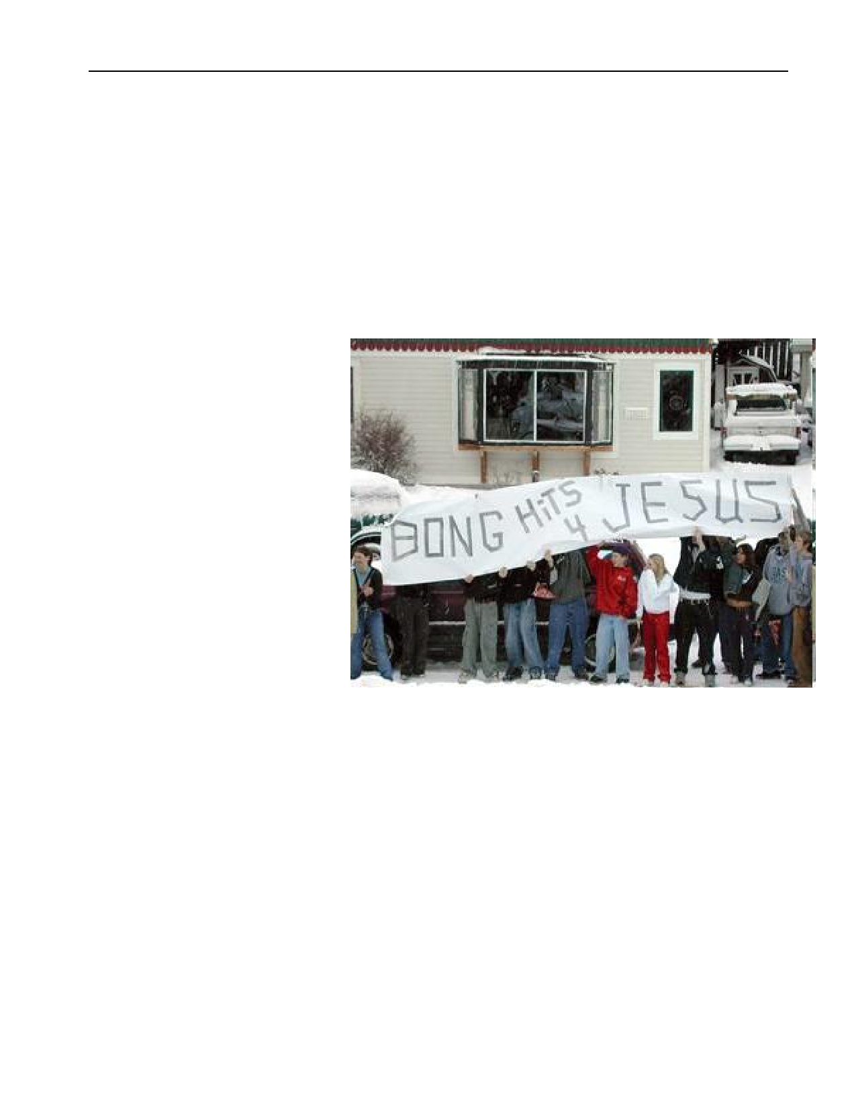
Should public schools ban student speech that refers to sex or
drugs?

Morse v. Frederick (2007)
Facts of the Case: At a school-supervised event, Joseph Frederick held up a banner with the
message ―Bong Hits 4 Jesus,‖ a slang reference to marijuana smoking. Principal Deborah
Morse took away the banner and suspended Frederick for ten days. She justified her actions
by citing the school's policy against the display of material that promotes the use of illegal drugs.

Constitutional Question: Does the First Amendment allow public schools to prohibit
students from displaying
messages promoting the use of
illegal drugs at school-
supervised events?

Conclusion: Yes.

From the Majority Opinion:
―At least two interpretations of
the words on the banner
demonstrate that the sign
advocated the use of illegal
drugs. First, the phrase could be
interpreted as an imperative:
‗[Take] bong hits …'—a message equivalent, as [Principal] Morse explained in her declaration, to
‗smoke marijuana' or ‗use an
illegal drug.' Alternatively, the
phrase could be viewed as celebrating drug use—‗bong hits [are a good thing],' or ‗[we take]
bong hits. . . . '

―The question thus becomes whether a principal may, consistent with the First Amendment , restrict student speech at a school event, when that speech is reasonably viewed as promoting illegal drug use. We hold that she may. . . .

―Tinker held that student expression may not be suppressed unless school officials reasonably
conclude that it will ‗materially and substantially disrupt the work and discipline of the school. . . .

―Congress has declared that part of a school's job is educating students about the dangers of
illegal drug use. . . . Thousands of school boards throughout the country. . . [have
acknowledged that] peer pressure is perhaps ‗the single most important factor leading
schoolchildren to take drugs,' and that students are more likely to use drugs when the norms
in school appear to tolerate such behavior. . . . Tinker warned that schools may not prohibit student speech because of ‗undifferentiated fear or apprehension of disturbance' or ‗a mere
8

desire to avoid the discomfort and unpleasantness that always accompany an unpopular
viewpoint.' The danger here is far more serious and palpable. The particular concern to
prevent student drug abuse at issue here, embodied in established school policy, extends well
beyond an abstract desire to avoid controversy.‖

From a Dissenting Opinion: ―In my judgment, the First Amendment protects student
speech if the message itself neither violates a permissible rule nor expressly advocates
conduct that is illegal and harmful to students. This nonsense banner does neither, and the Court does serious violence to the First Amendment in upholding. . . a school's decision to punish Frederick for expressing a view with which it disagreed. . . .

―This is a nonsense message. . . . Admittedly, some high school students (including those who
use drugs) are dumb. Most students, however, do not shed their brains at the schoolhouse
gate, and most students know dumb advocacy when they see it. The notion that the message
on this banner would actually persuade either the average student or even the dumbest one to
change his or her behavior is most implausible. That the Court believes such a silly message can be [restricted] . . . suggests that the principle it articulates has no stopping point.

―Even if . . . Frederick's obtuse reference to marijuana [could be understood as advocating
marijuana use], that advocacy was at best… ambiguous. There is abundant precedent. . . for the proposition that when the ‗First Amendment is implicated, the tie goes to the speaker….' If this were a close case, the tie would have to go to Frederick's speech, not to the principal's strained reading of his [vague] message. . . .

―Even in high school, a rule that permits only one point of view to be expressed is less likely to
produce correct answers than the open discussion of countervailing views. In the national
debate about a serious issue, it is the expression of the minority's viewpoint that most
demands the protection of the First Amendment . Whatever the better policy may be, a full
and frank discussion of the costs and benefits of the attempt to prohibit the use of marijuana
is far wiser than suppression of speech because it is unpopular.‖

----------------------------------------------------------------------------------------
Bethel School District v. Fraser (478 U.S. 675, 1986)
Free Expression for Students
The Issue
Does the First Amendment prevent a school district from disciplining a high school student for giving a lewd speech at a high school assembly?
Facts and Background
Mathew Fraser, a senior at Bethel High School in Bethel, Washington, spoke to a school assembly to nominate a classmate for an office in student government. His speech was filled with sexual references and innuendos, but it contained no obscenities. The good news is that Fraser's candidate was overwhelmingly elected. The bad news was that Fraser was suspended from the school for three days and removed from the list of students who were eligible to make graduation remarks. (Fraser was second in his class at that time.) His parents appealed the school's disciplinary action. The Washington Supreme Court agreed that his free speech rights had been violated. The school board then appealed the case to the U.S. Supreme Court.
The Decision
The Court had earlier held, in Tinker v. Des Moines Independent School Board, that students do not shed their constitutional rights at the school gate. In that case, the Court said that the First Amendment gave students the right to wear black armbands to school to protest the Vietnam War.
In the Bethel case, however, the Court upheld the school district. The Court held, by a 7-2 margin, that school officials acted within the Constitution by disciplining Fraser. Chief Justice Burger wrote for the majority. He pointed out that there was a huge difference between the protest in Tinker, which dealt with a major issue of public policy, and the lewdness of Fraser's speech. "The purpose of public education in America is to teach fundamental values," he wrote. "These fundamental values…must…include consideration of the political sensibilities of other students."
Burger conceded that the First Amendment might permit the use of an offensive form of expression by an adult making a political point, but "the same latitude of expression is not permitted to children in a public school."
Justices Stevens and Marshall dissented. Stevens wrote, "I believe a strong presumption in favor of free expression should apply whenever an issue of this kind is arguable."
The Impact of the Decision
Along with Hazelwood School District et al. v. Kuhlmeier et al (1988), a case involving a school district that censored a student newspaper, the Bethel case shows the Court re-examining the issue of student expression in the schools and finding that certain limits on expression are permitted by the First Amendment.
Hazelwood School District v. Kuhlmeier, 484 U.S. 260 (1988)
The First Amendment rights of student journalists are not violated when school officials prevent the publication of certain articles in the school newspaper.
Background: Journalism students in Hazelwood East High School in St. Louis produced a school sponsored and funded newspaper called the Spectrum. One issue featured stories on teen pregnancy and divorce. The school's principal thought the stories were inappropriate and prior to the publication, he deleted the two pages containing the offensive stories without telling the journalism students. The students were upset because they had not been given the opportunity to make changes, and because several other non-offensive articles were also deleted when the pages were removed. The students felt their First Amendment rights had been violated and took their case to the U.S. District Court for the Eastern District of Missouri. The court sided with the school, ruling that the school had the authority to remove the articles written as part of the school's curriculum. The students appealed the decision to the U.S. Court of Appeals for the Eighth Circuit. The appeals court reversed the lower court, finding that the paper was a "public forum" and that school officials could censor its content only under extreme circumstances. Unhappy with the ruling, the school appealed the decision to the U.S. Supreme Court.
Decision: In 1988, the Supreme Court, with one vacancy, handed down a 5-3 decision in favor of the school. The Court reversed the appellate court, and said that public schools do not have to allow student speech if it is inconsistent with the schools' educational mission. Even if the government can't censor such speech outside of school, public schools have the authority to limit that speech.
The First Amendment protects the freedom of the press. Before the American Revolution, English authorities often censored the press in order to ensure that articles critical of the government were not widely circulated. The Founders knew that a free press was essential for the promotion of ideas.
The Supreme Court of the United States has been highly critical of any attempt to impose a prior restraint on the press, i.e., prohibiting a paper from publishing a story. The Court has even made it harder for individuals to sue newspapers for libel and slander.
Today, suits involving freedom of the press are still prevalent in the courts. Some prominent issues are: 1) What constitutes "the press" in an age when many people can create their own blog on the Internet? 2) Must reporters reveal their sources when ordered to by legal authorities?

