Free Response Question on Congress

On Friday, March 1, you will answer the Free Response Question in class (Lab Room 203). You will NOT be able to have notes but I am giving you the question so you are prepared to answer the question. The AP US Government test includes 4 free response questions. You have 25 minutes per question. You have to answer all questions. The following is an example of components of FRQ questions. (It is longer than the average FRQ).
--------------------------------------------------------------------------------------------------
Question:

1. Explain three ways the House and Senate bill making process is different. Include the House versus Senate process and include why and how they are different. (1 point per difference; 3 points for the explanation; up to 6 points)

2. Describe the roll and responsibilities of TWO of the following members of Congress: Speaker of the House, president pro tempore of the Senate, majority leaders of the House and/or Senate, minority leaders of the House and/or Senate, whips of the House and/or Senate. (2 points each; up to 4 points)

List how the TWO members you selected influence their party in Congress? (up to4 points)

Identify and explain ONE factor that makes it difficult for the TWO members you selected to influence members of their party in Congress. (up to 4 points)

3. List THREE ways current members of Congress benefit from incumbency. (up to 3 points)

How is party leadership related to incumbency? (up to 2 points)

What are advantages of incumbency? (up to 2 points)
What are disadvantages of incumbency? (up to 2 points)

4. Analyze the information on the graphs. (a) topic (1 point) (b) trend over 18 year period for each graph (3 points) (c) compare / contrast the data (3 points) and (d) what conclusions you might draw from the data (3 points)

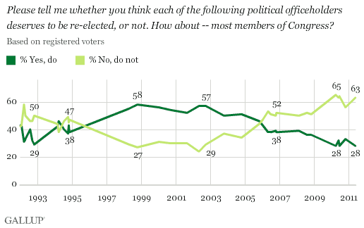

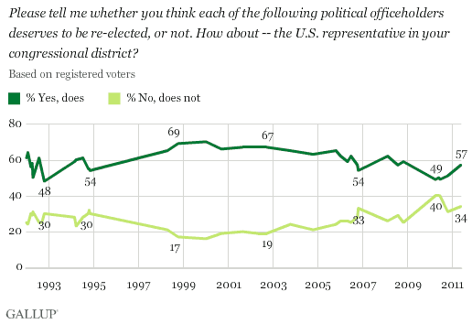

------------------------------------------------------

(37 points x 2 = 74 points)

